Capstone Project

Food Delivery

Travel app

Medicine app

Create the folder with as Capstone project

backend

spring boot project

1. Eureka-Server-App 8761 port number

With starter as Eureka server and web starter

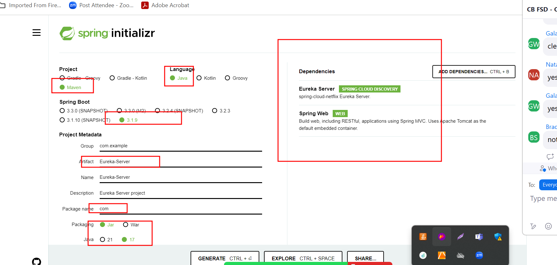

1. Food-delivery-client, travel-app, medicine-app 9090 port number

Dockerfile

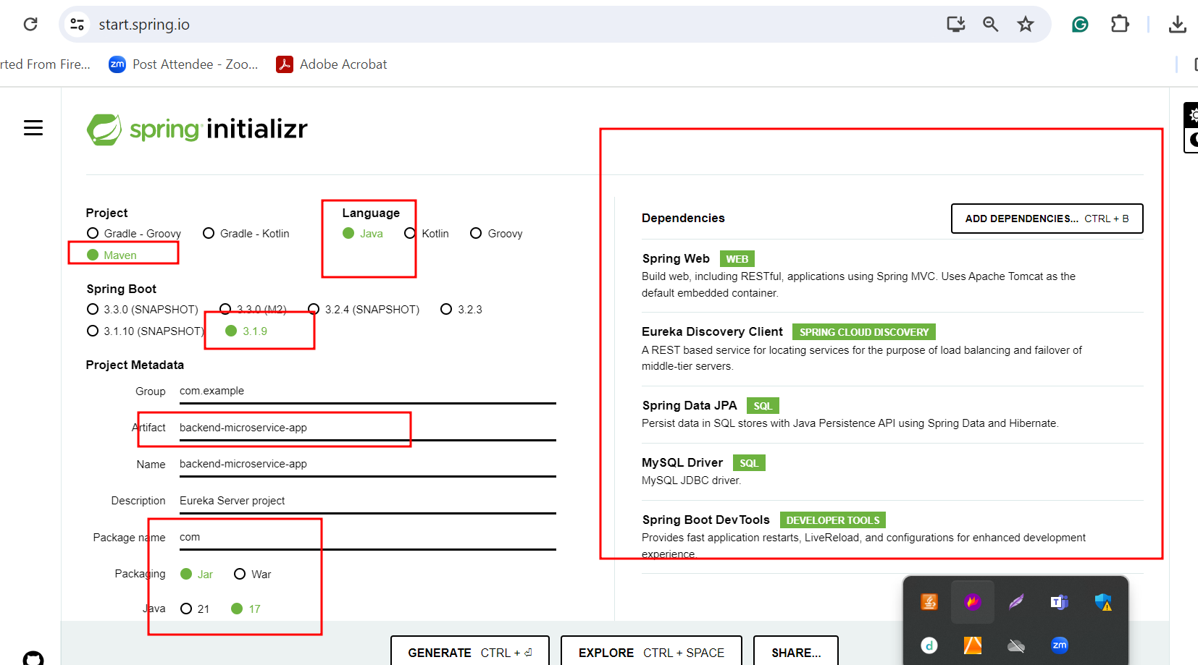

frontend

1. Food-delivery-frontend, travel-app-frontend, medicine-app-frontend

ng new frontend-app

routing 🡪 yes

styling 🡪 css

ng g c login

ng g c signup (customer)

ng g c admindashboard

ng g c customerdashboard

ng g class login ( model login details)

ng g s login two functionality for signin and signup

Dockerfile

docker-compose

we need to provide four containers

1. Mysql container
2. Frontend container
3. Eureka container
4. Backend container

Jenkinfile

EC2 instance :

Run jenkin in EC2 instance with pipeline to build the project.